Day in the Life of the Hudson River 10/14/21
Morris Canal Basin, New Jersey
RIVER MILE: 0.5
Salt Front: ~ 49
Hudson Montessori School- Grace Sanvictores & Michelle Velho
61 students (grades 1-6) & 9 adults
Latitude & Longitude – Latitude 40.719 N & Longitude – 74.050 W
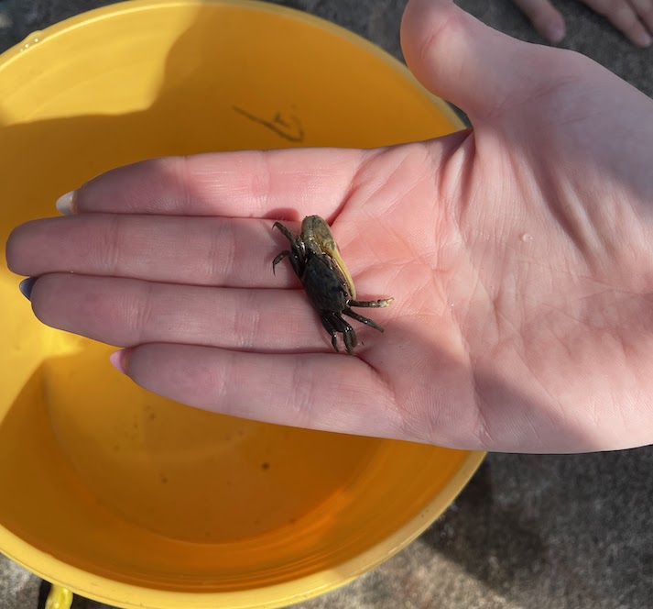
Fiddler Crab!
Location: Morris Canal Park, Jersey City (behind the colgate clock)
Area: A park with a grassy area overlooking Manhattan and a boardwalk with steps which lead to the water behind the Colgate clock.
Surrounding Land Use: 100% Urban/residential
Sampling Site: Pier; grass; riprap (large rocks)
Shoreline: 30% Sandy; 70% Rocky
Water: Calm
Plants in area: No aquatic plants in the area; algae and moss present
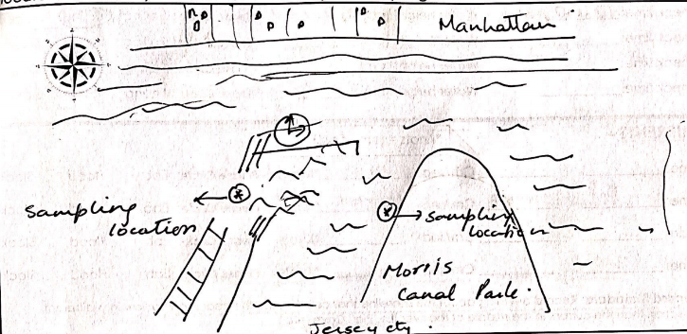

*NR = Not read/recorded
ITEM |  | Time |  | Reading |  |  |  | Comments
Physical
Air Temperature |  | 9:30 AM  11:00 AM  12:00 PM |  | 26.1 º C  26.7 º C  27.8 º C |  |  | 79 º F  80 º F  82 º F
Wind Speed: |  | 10:30 AM |  | Anemometer  2.5 m/s |  |  | Beaufort  1 | Direction  N
Weather today |  | 12:00 PM |  | <25% cloud cover |  |  | No rain
Weather the past 3 days: |  | No rain
Tides- |  | Time |  | Rising, Falling, Unchanged |  |  | Height (cm)
 |  | 9:45 AM  11:00 AM  12:00 PM |  | NR  Rising  Rising |  |  | 15 cm  30 cm  40 cm
Current- |  | Time |  | Cm/sec |  | Knots | North/South | Ebb/Flood/Slack
 |  | 10:00 AM |  | NR |  | NR | South | Ebb
Water Temperature- |  | 10:00 AM  11:45 AM |  | 20º C  20º C |  |  | 68 º F  68 º F
Turbidity- Long Sight Tube |  | 9:45 AM  11:45 AM |  | 30.6 cm (avg)  42.66 cm (avg) |  |  | Secchi Disk used 10:30 AM = 39.3 cm (avg)
Chemical
Salinity- Hydrometer |  | 10:00 AM  12:00 PM |  | 17.7 ppt (avg)  17 ppt (avg)
Standardized Salinity- Refractometer |  | 11:30 AM |  | 15 ppt
DO – Drop Count kit |  | Time |  | Temp |  |  | ppm DO | % Saturation
 |  | 10:00 AM  11:30 AM |  | 20 º C  20 º C |  |  | 8  9 | 90%  100%
pH – Test Stripes |  | 10:00 AM |  | 6
Nitrates- NR
Phosphates- NR
Biological
Fish -NA |  | Number |  | Name |  |  | Length of longest | Length of smallest
*did not seine, did a kick net and oyster cage
Fish Totals |  | TOTAL: |  | Diversity:
Macroinvertebrates |  | Number |  | Name |  |  | Length of longest | Length of smallest
 |  | 1  14  1  1  3  6 |  | Blue Crab  Asian Shore Crab  Fiddler Crab  Shrimp sp.  Amphipods  Ribbed mussels |  |  | 1.5 cm  5 cm  NR  3.5 cm  1 cm  0.5 cm | 2.5 cm  3 cm  NR  NR
Macroinvertebrate Totals |  | TOTAL:26 |  | Diversity: 6 |  |  |  | *Blue crab was a male. Fiddler crab was a male. 3 males and 2 female asian shore crabs.
Sediment Core
Length | H2S smell |  | Oxid Top |  | Oil |  | Grain Size | Other Features
NR | No |  | No |  | No |  | Common: clay, mud, and sand  Rare: gravel | Rare: shells mussels
Boats
 | Time |  | Name |  | Color |  | North/Southbound | Light/Loaded
Commercial | NR |  | Barges |  | NR |  | Southbound | Loaded
Residential | NR |  | Liberty Landing Ferry |  | Yellow |  | Northbound | Loaded

